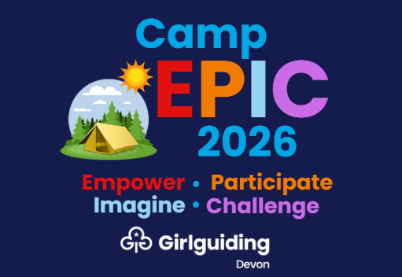

Girlguiding Devon Camp EPIC 2026
Information for Parents and Carers
Dear Parent/Carer,
We are delighted to invite your child to take part in Camp EPIC 2026, Girlguiding Devon’s large-scale county camp, taking place from Friday 4 to Sunday 6 September 2026 at the River Dart Country Park.
This exciting event will bring together hundreds of Rainbows, Brownies, Guides, Rangers, Young Leaders, volunteers and leaders from across Devon for a truly memorable weekend of fun, friendship, adventure and discovery.
EPIC stands for Empower, Participate, Imagine and Challenge – and that’s exactly what this weekend is all about. Girls will have the opportunity to try new things, build confidence, learn skills, be inspired and create lifelong memories.
The cost of the event includes all activities, accommodation and food for the weekend, and there will be a wide range of adventurous, creative, outdoor and team-building experiences on offer, led by trained instructors and experienced Girlguiding volunteers. River Dart Country Park is a specialist site with excellent facilities and expertise in hosting safe, active and enjoyable residential events for young people.
Camp EPIC is designed to be fully inclusive, and we are committed to making sure every girl has the opportunity to take part, whatever her needs, background or circumstances.
We also take safety, safeguarding, welfare and wellbeing seriously, and are working closely with River Dart Country Park and Girlguiding Devon’s welfare, safeguarding, accessibility and medical teams to ensure every participant is safe, supported and able to enjoy the experience.

We know that as parents and carers you may have questions, so we have created a detailed event website with comprehensive FAQs, covering everything from safety and accommodation to activities, drop-off arrangements and medical information. This information will be updated as details are finalised – so do keep checking in to keep up to date.
👉 Visit the Camp EPIC 2026 website: https://devonguides.org.uk/events/camp-epic-2026
If you have further questions, you are welcome to speak to your unit’s leaders or email the Camp EPIC team at campepic2026@devonguides.org.uk.
In due course, your child’s unit will send further information, including health, dietary and consent forms, kit lists and travel arrangements.
Finally, to keep up to date with Camp EPIC news, countdowns, sneak peeks and behind-the-scenes planning, don’t forget to follow Girlguiding Devon on our social media channels. We’ll be sharing updates, activity highlights, reminders and lots of excitement as we get closer to the big weekend! You may even spot your daughter’s unit featured as preparations unfold.
Follow us here:
📘 Facebook: @devongirlguiding
📸 Instagram: @devongirlguiding
🎵 TikTok: @girlguiding.devon
▶️ YouTube: @girlguidingdevon2834
We cannot wait to welcome your child to Camp EPIC 2026 – where every girl will have the chance to Empower, Participate, Imagine and Challenge!
With excitement,
Cara Bennett
Camp Leader
Girlguiding Devon — Camp EPIC 2026

