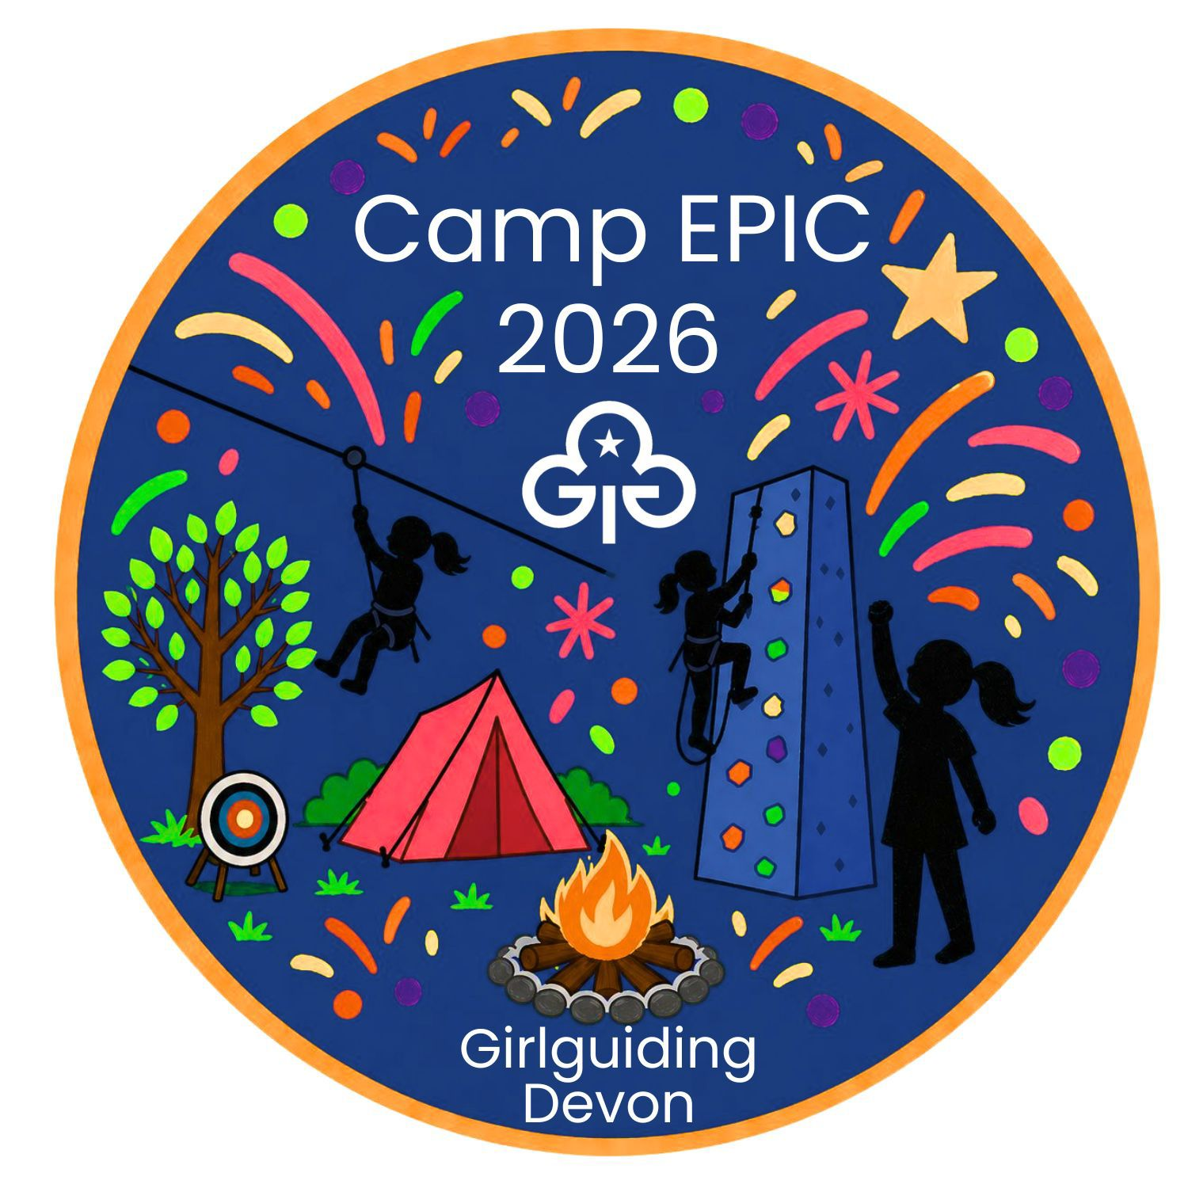


Parking Permit
To be completed prior to arrival and displayed in the front windscreen of any vehicle requiring access to River Dart Country Park for Camp EPIC 2026

Campsite (please put a X in the box)
Riverside
Lower Riverside
Meadows
Picnic Meadow
Village Green
Woodlands

Pitch Number

Or
put a X in one of the following boxes:

Indoor
Accommodation
Day
Visitor

Name: __________________________________________
Unit / group: ______________________________________
Mobile Phone Number: ________________________________

